STUDENT GRADE CALCULATOR SYSTEM FOR COMPUTING AND TRACKING STUDENT GRADES

BY:

GROUP 4 - ILANG-ILANG

Ibon, Gian Alexander D.

Kasala, Maru Fabian G.

Manalo, Kharlie Zhean M.

Marasigan, Myke Hanz Anjelo P.

Melo, Eros Nikolai C.

Philippine Science High School CALABARZON Region Campus

Computer Science 2

Amy U. Aclan

- Problem Statement
Students often compute their grades manually using calculators or spreadsheets, especially when dealing with multiple academic components such as quizzes, examinations, laboratory activities, and projects with different weight percentages. This process is time-consuming and prone to errors, inconsistencies, and misunderstandings of how final grades are calculated. Additionally, students experience difficulty tracking their performance across multiple subjects and grading periods. Without a centralized system, grade records become scattered, making it difficult to monitor progress and identify areas that require improvement.
Although spreadsheet tools can assist with computations, they are not always user-friendly for students who are unfamiliar with formulas or data organization. Therefore, there is a need for a centralized, accessible system that simplifies grade computation while improving accuracy and organization. This project addresses the need by developing a web-based Student Grade Calculator System that automates computations and provides a structured platform for tracking and analyzing academic performance.
- Project Overview and Relevance
The Student Grade Calculator System is a web-based application designed to help students compute, organize, and track their academic grades across different subjects and grading periods. It allows users to input raw scores for various assessment components and automatically applies predefined weight distributions to compute final grades accurately. The application features a user-friendly interface developed using HTML, CSS, and JavaScript, ensuring accessibility and ease of use. The backend is powered by Python, which handles data processing, grade computation, and communication with the database through the Flask framework, while a SQLite database is used to store student records, subject information, and computed results, enabling structured and persistent data management.
The system includes key features such as automated grade computation based on weighted components; CRUD operations for managing student and subject records; centralized grade storage using a database; real-time display of computed results; basic data analysis, such as average grade calculation per subject; and a structured dashboard for tracking academic performance.
This project demonstrates the integration of core computing concepts, including web development, backend programming, database management, and basic data analysis. It highlights the use of Python as a backend technology for dynamic web applications. The project is relevant in both academic and real-world contexts, as it reflects how modern systems manage data processing, user interaction, and persistent storage, while also introducing fundamental full-stack development concepts commonly used in software engineering.

- Objectives of the Study
The objective of the study is to develop a Student Grade Calculator System that automates the computation and tracking of student grades across multiple subjects and grading periods. The system aims to accurately process raw scores with corresponding weight percentages to generate final grades per subject. It also seeks to provide a structured system for storing and retrieving academic records using a database, ensuring that data is organized and easily accessible. In addition, the study focuses on developing a user-friendly web interface for inputting and viewing grade data, as well as generating a report-style display that presents grades in a clear and organized format. The system is also designed to compute the General Weighted Average (GWA) based on all subject grades and determine pass or fail status based on the computed results. Overall, it ensures consistency and accuracy in grade calculations across multiple users and sessions.

- Methodology
The system will be developed using a client-server architecture, where the frontend and backend are separated but communicate through HTTP requests, ensuring that data remains consistent and accessible across multiple users and sessions.
The frontend will be developed using HTML, CSS, and JavaScript. HTML will be used for structuring the interface, CSS for styling, and JavaScript for interactivity. Through this interface, users will be able to input grades for different components, select subjects and grading periods, and view computed results dynamically. JavaScript will also handle sending user inputs to the backend through API requests and updating the interface based on returned responses.
The backend will be implemented using Python with the Flask framework. It will receive data from the frontend, such as grades, weights, and subject information, then perform computations, including weighted grades, averages, and General Weighted Average (GWA). It will also validate input data to ensure accuracy and return processed results to the frontend. Flask will serve as the bridge between the frontend and backend through RESTful API endpoints.
A SQLite database will be used to store student profiles, subject information, grade records per grading period, and computed results. CRUD operations will be implemented to allow creating new grade entries, reading existing records, updating grades when necessary, and deleting incorrect or outdated data. This ensures data persistence and allows users to access and manage their records consistently across sessions.
For data processing and analysis, the system will compute weighted grades per subject, calculate quarterly averages, generate the General Weighted Average (GWA), and determine pass or fail status. Python functions will handle these computations to ensure accurate and consistent processing of all grade data.
Finally, system integration will connect all components into a unified workflow, where the frontend sends requests, the backend processes data, the database stores or retrieves information, and the backend returns responses for display. This ensures smooth interaction between all parts of the system and provides a seamless user experience with real-time computation.
- Flowchart
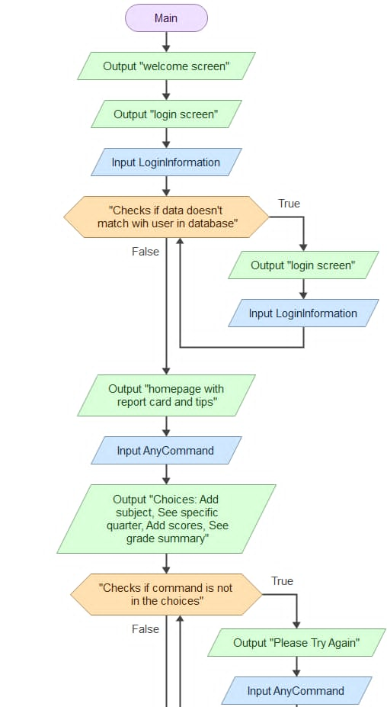

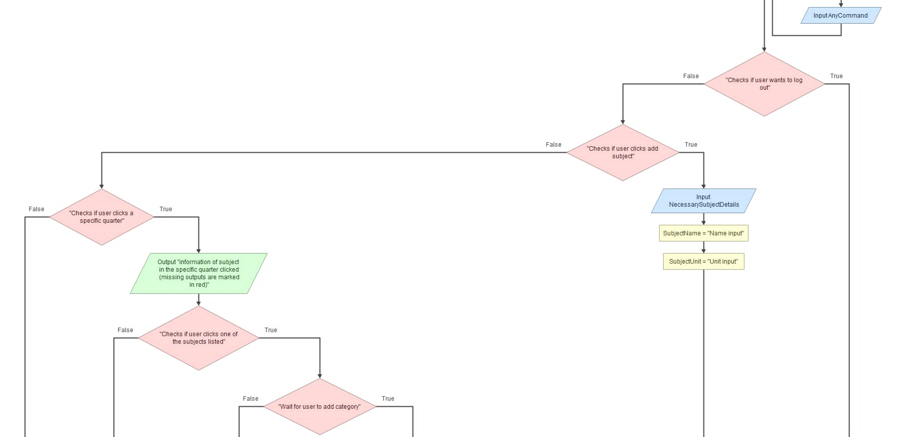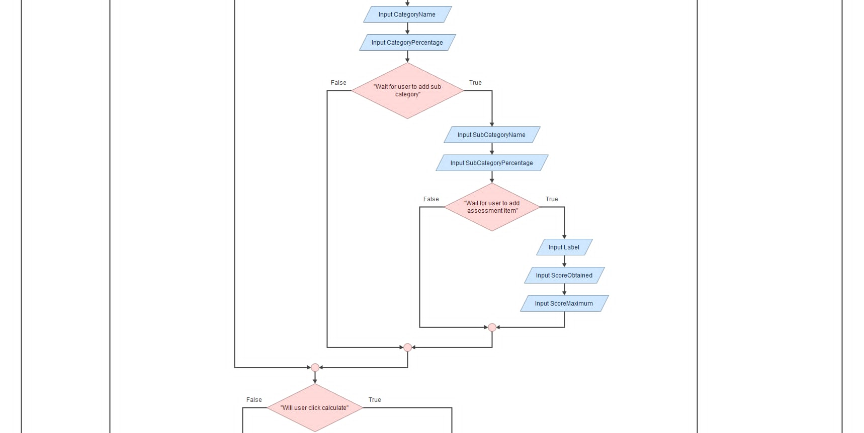
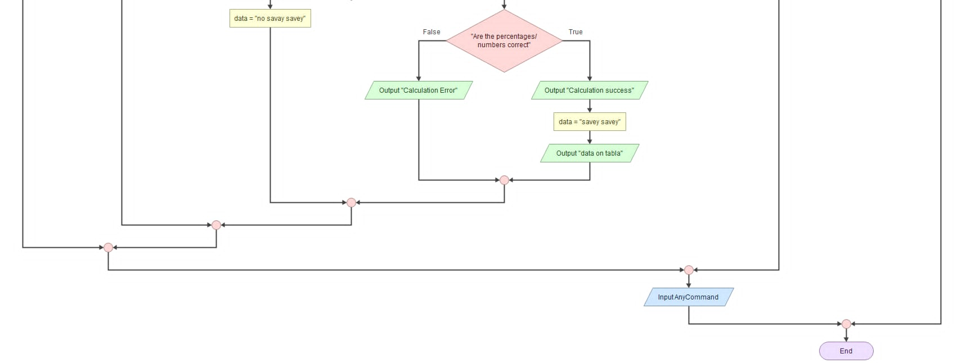

- Program

- Python
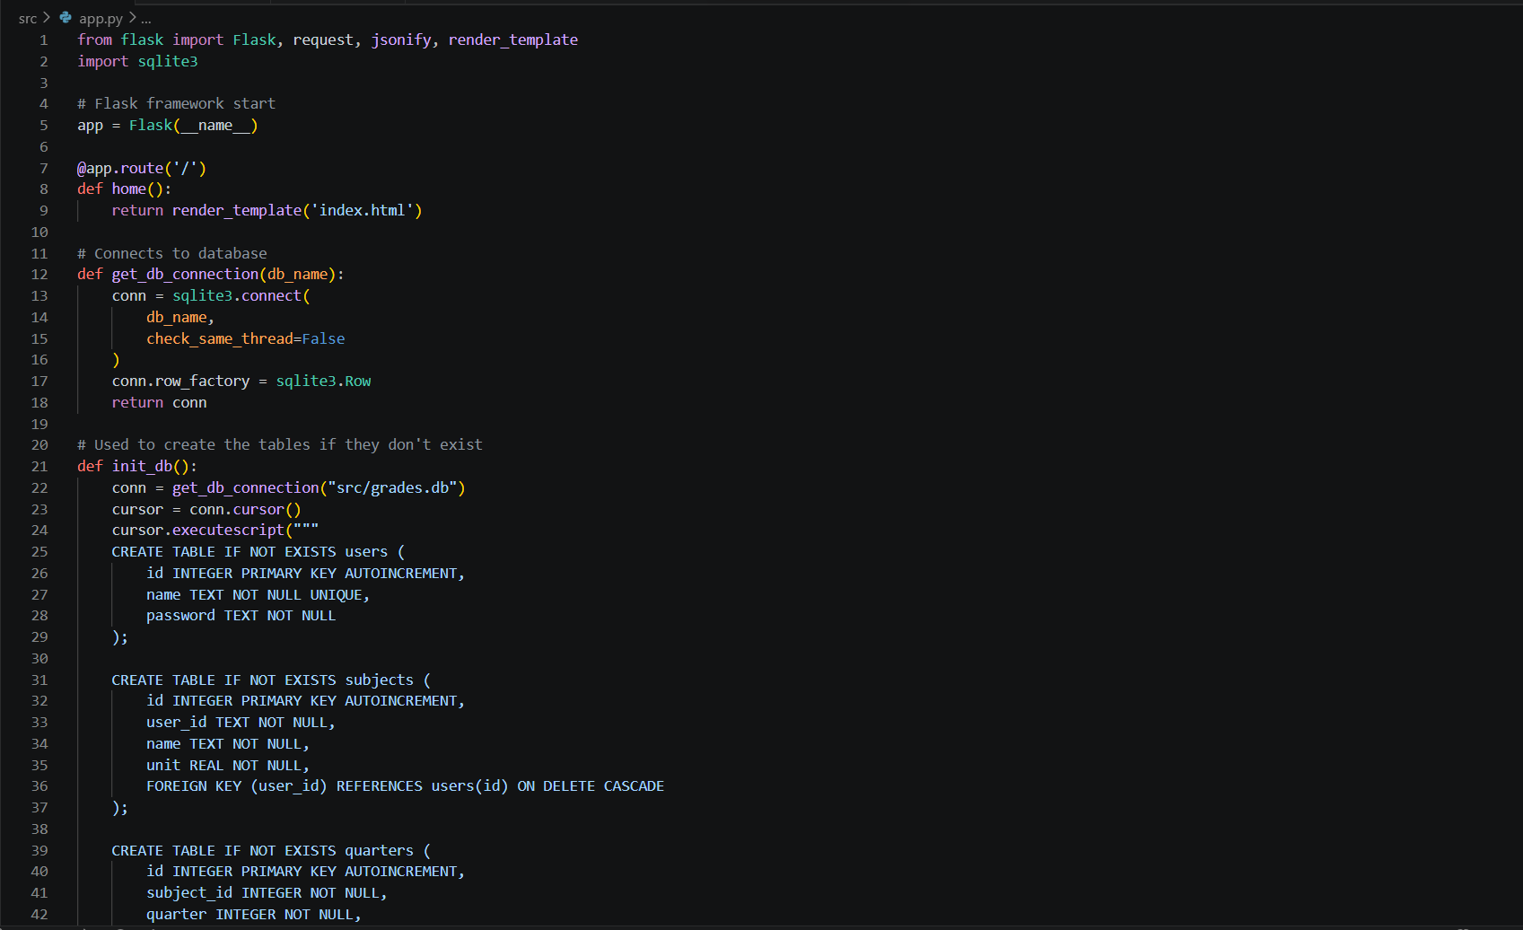
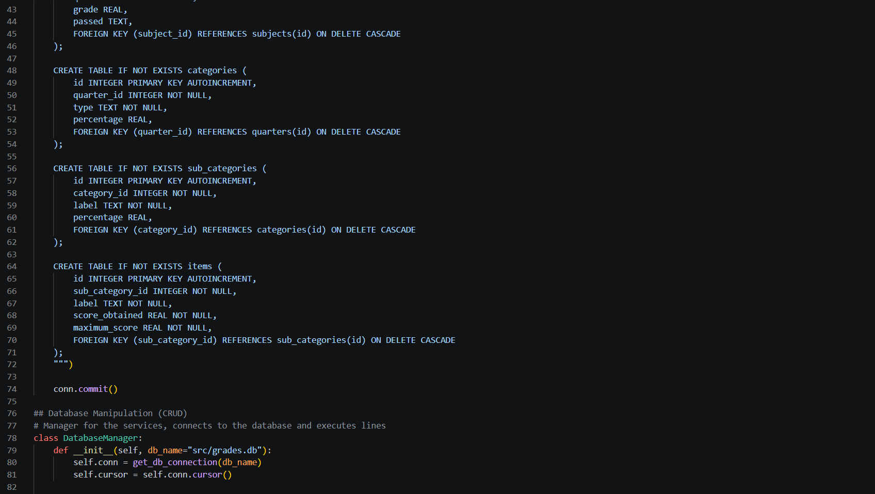

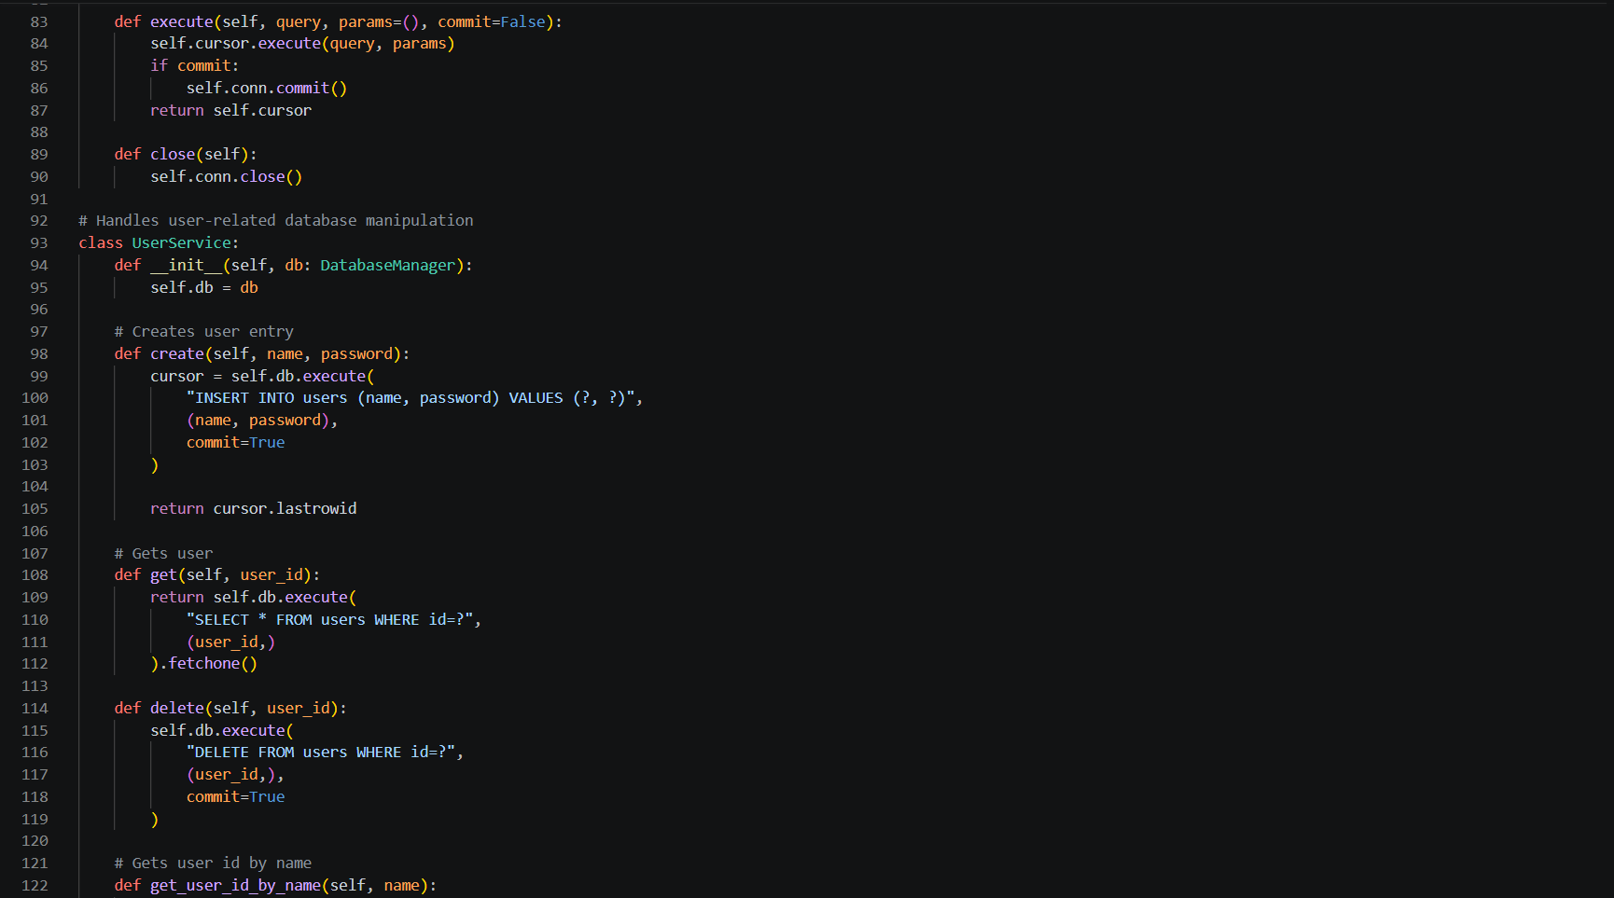
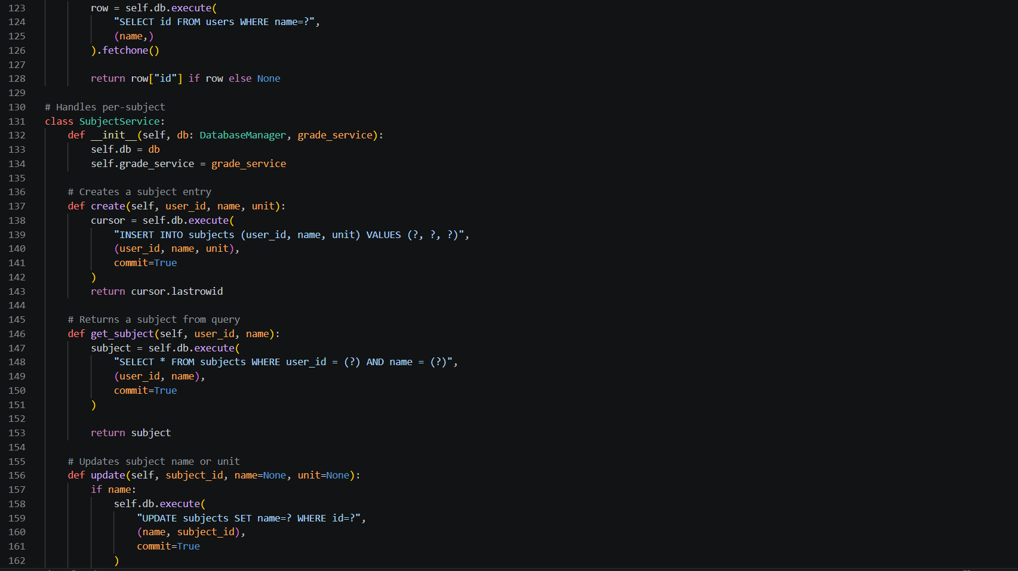

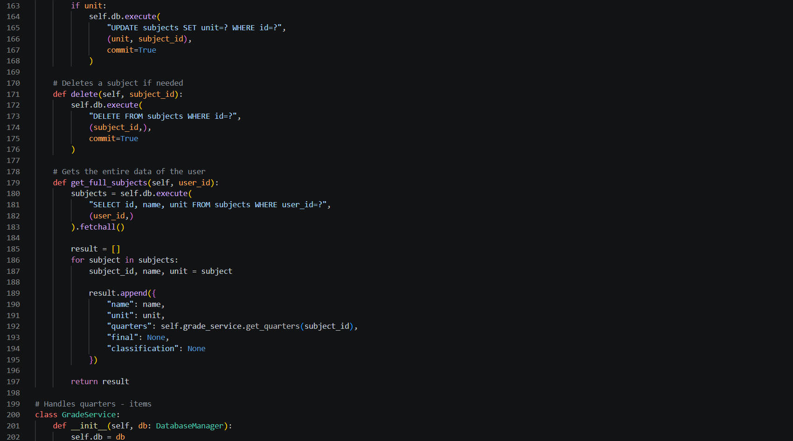

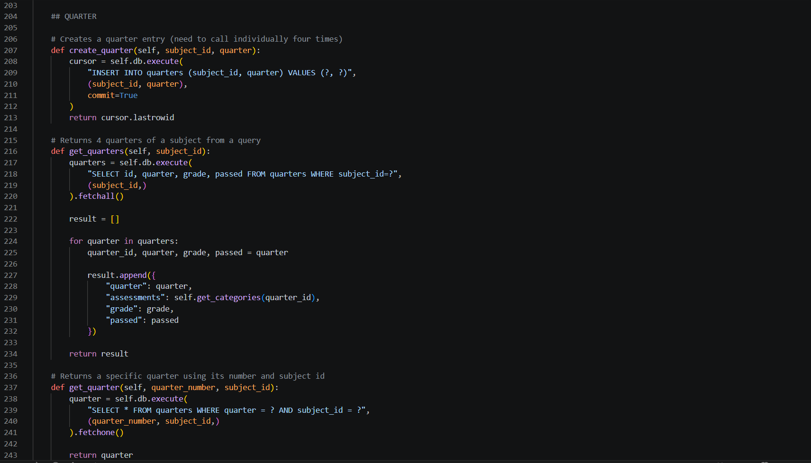

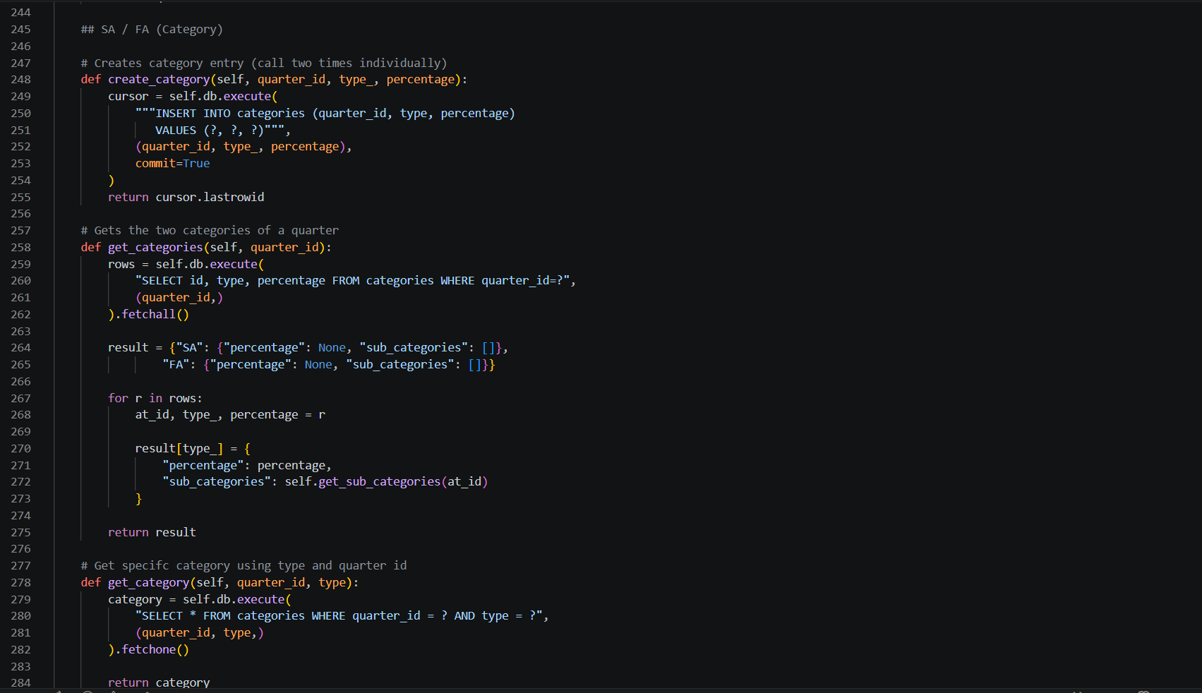

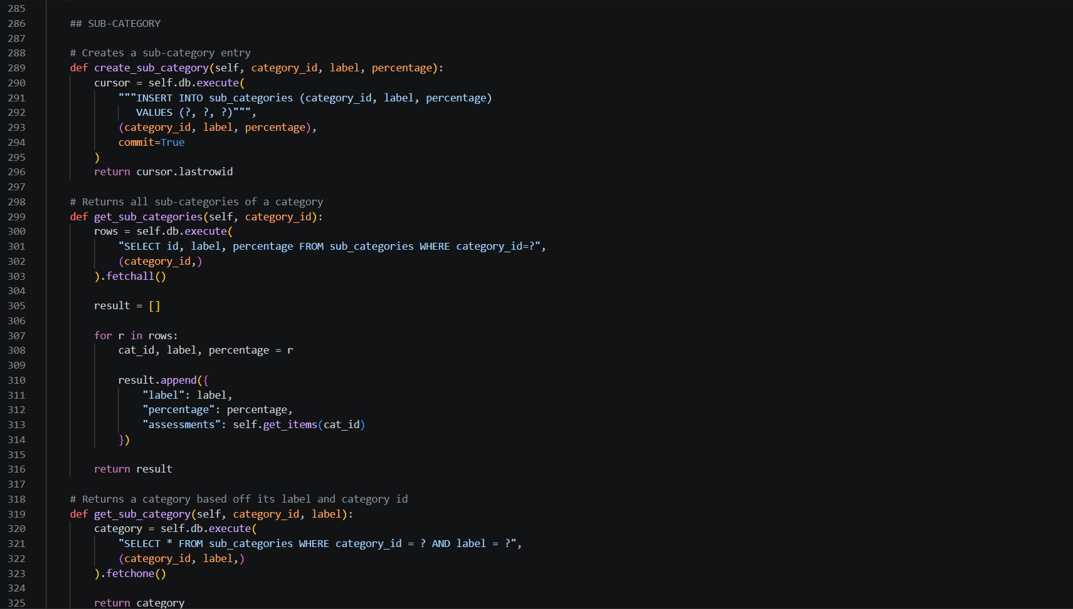

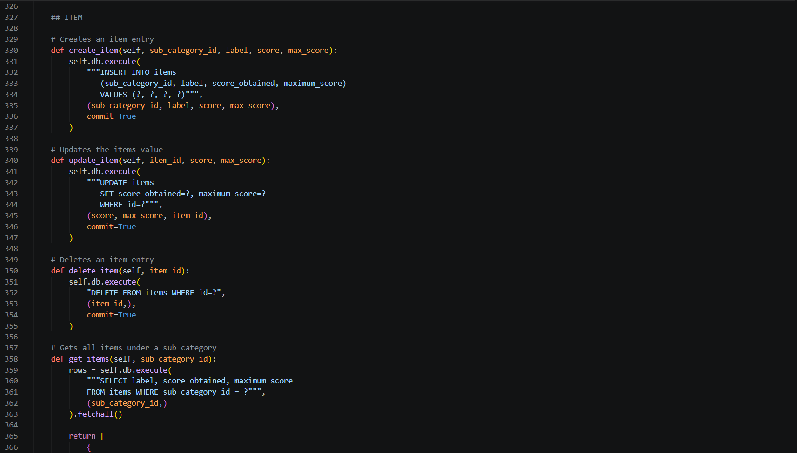

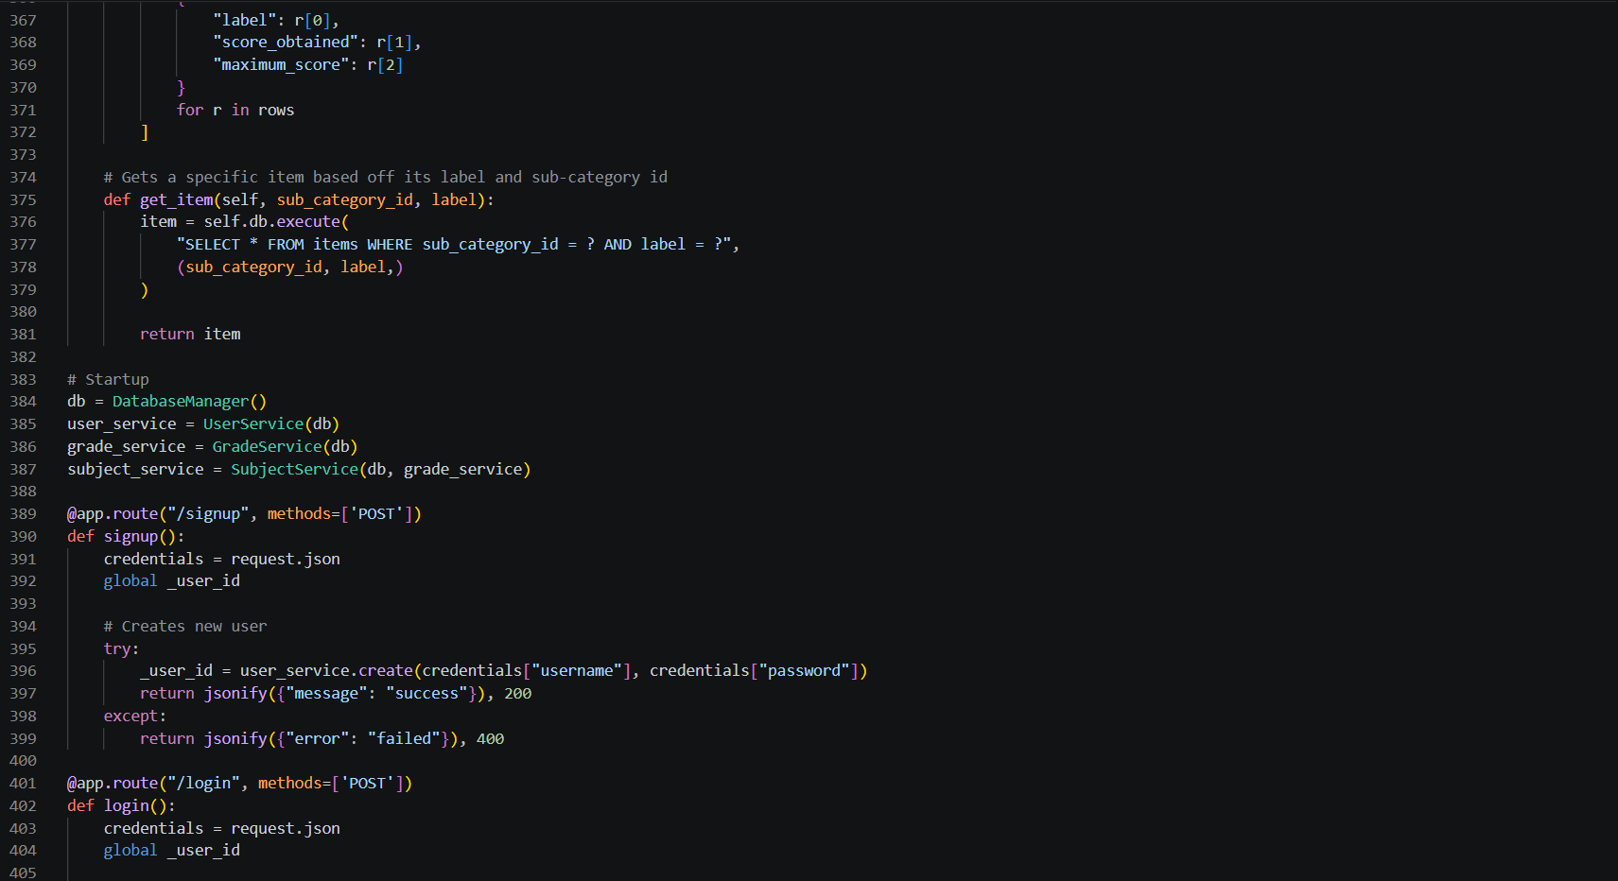

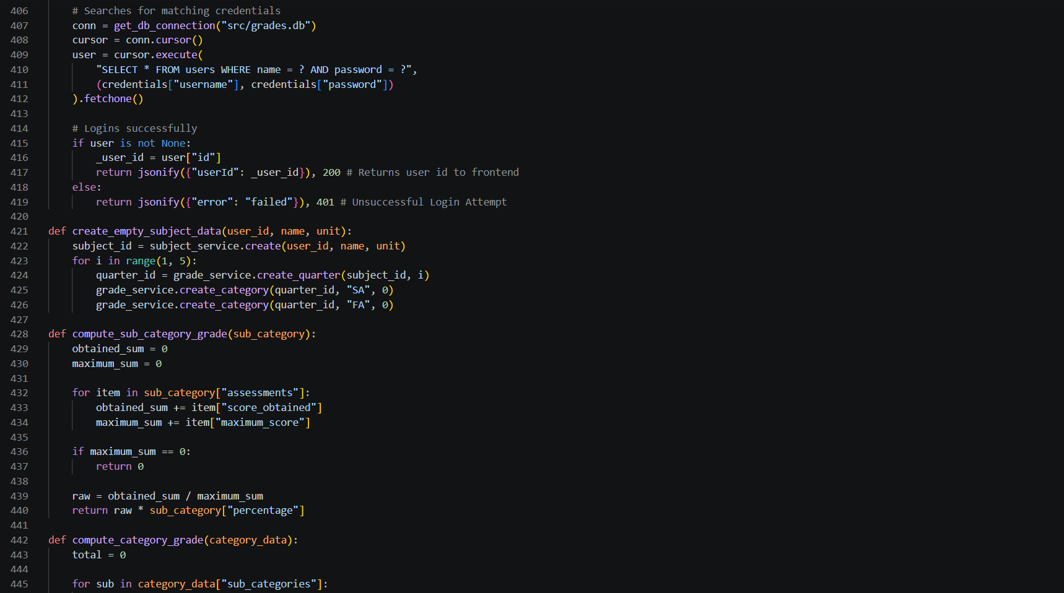

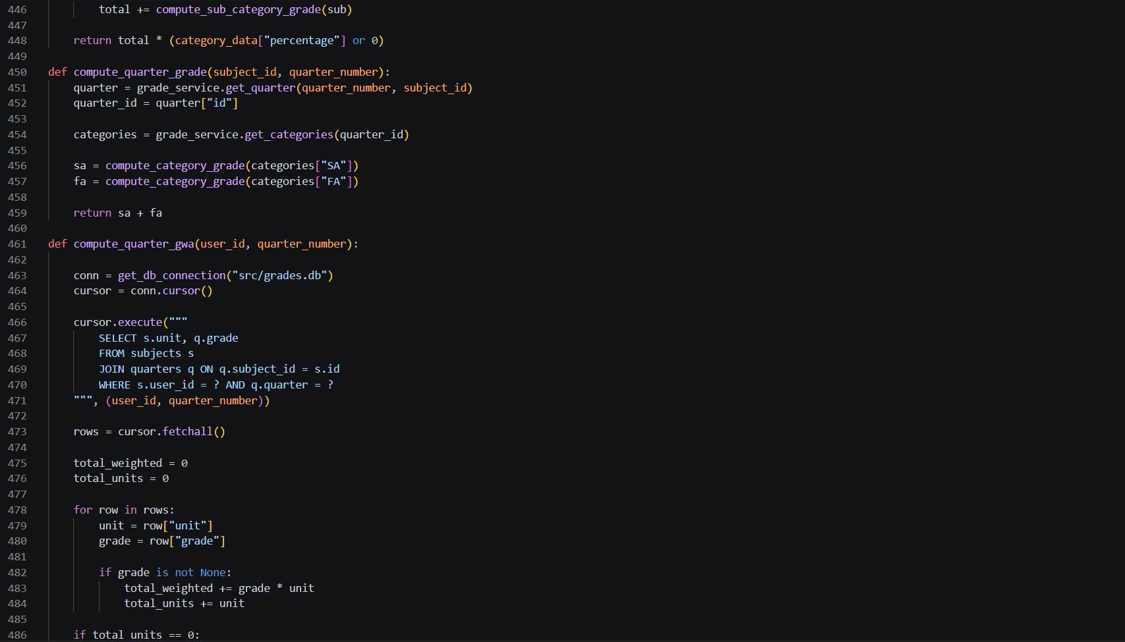

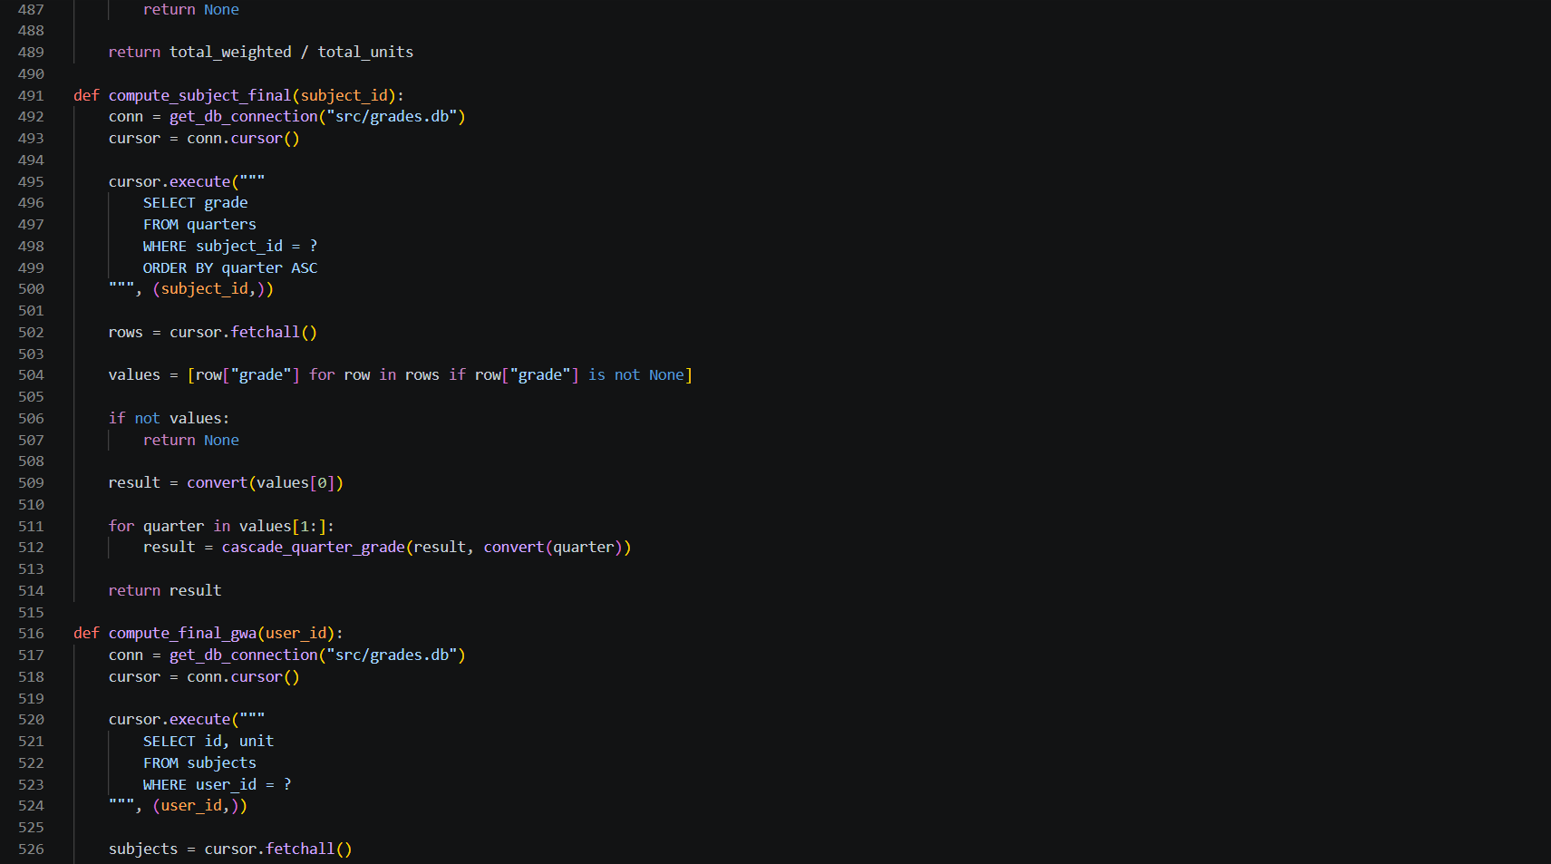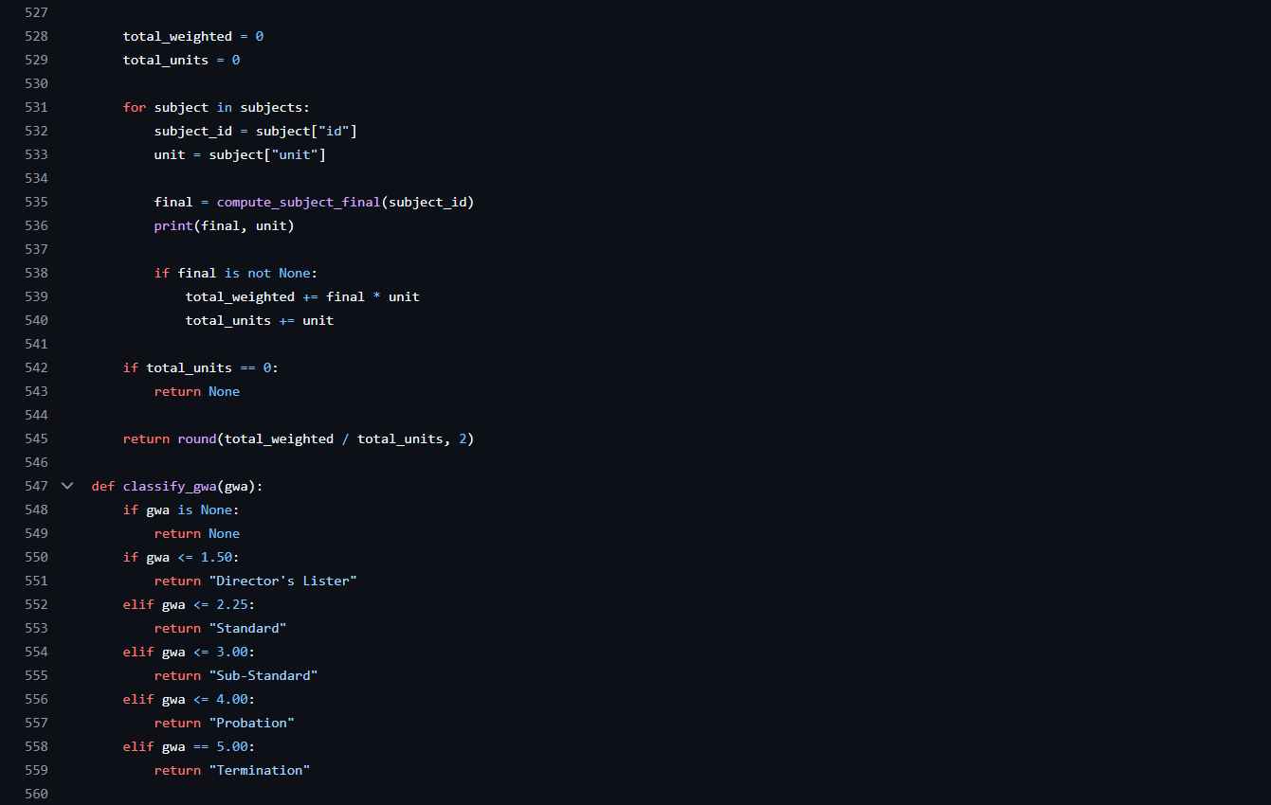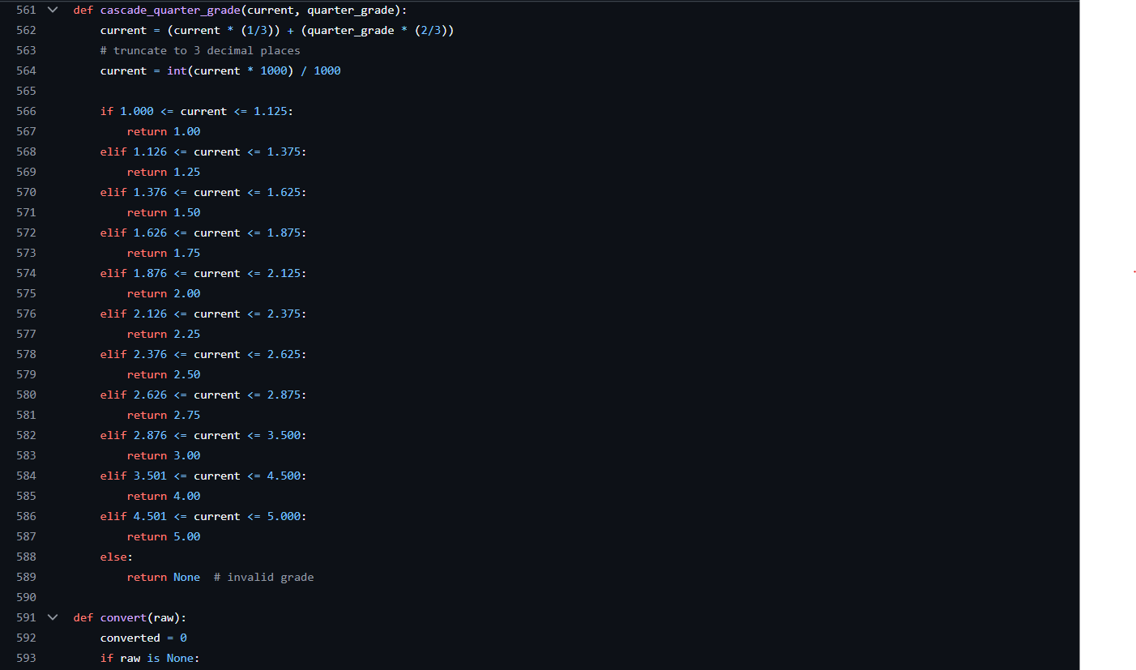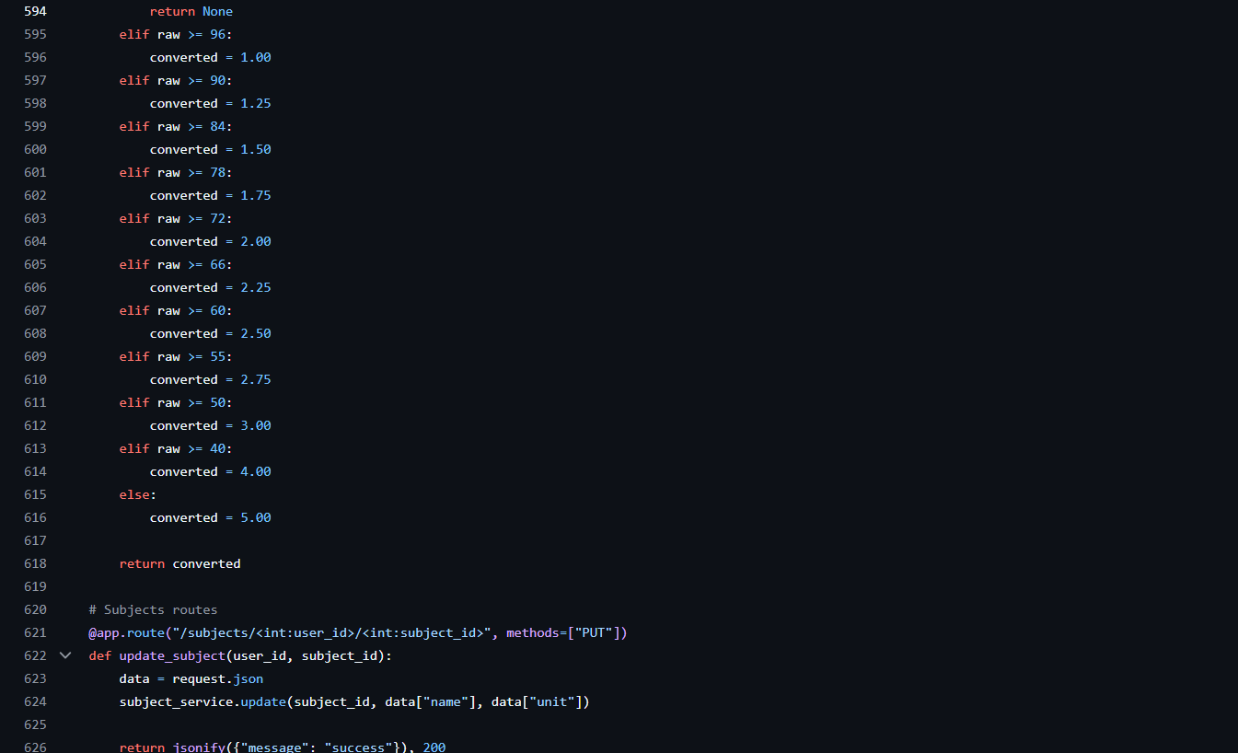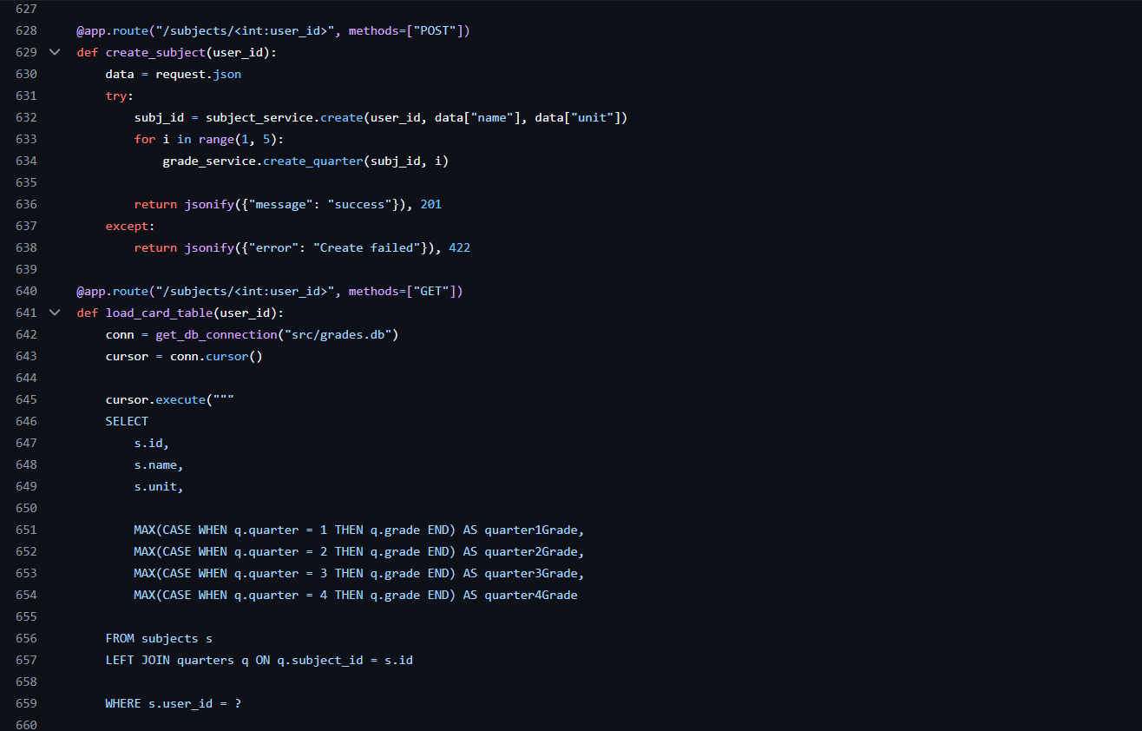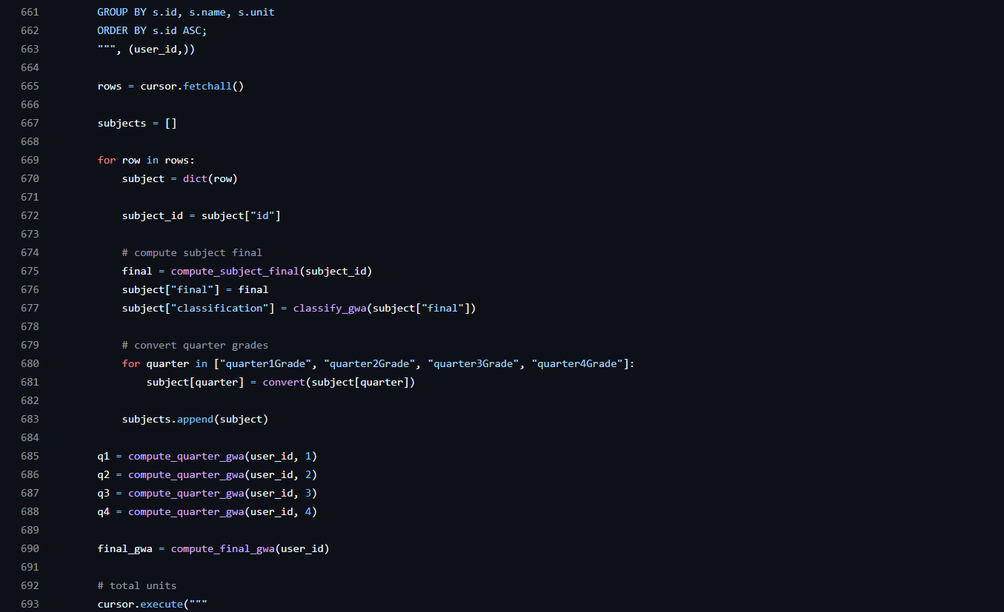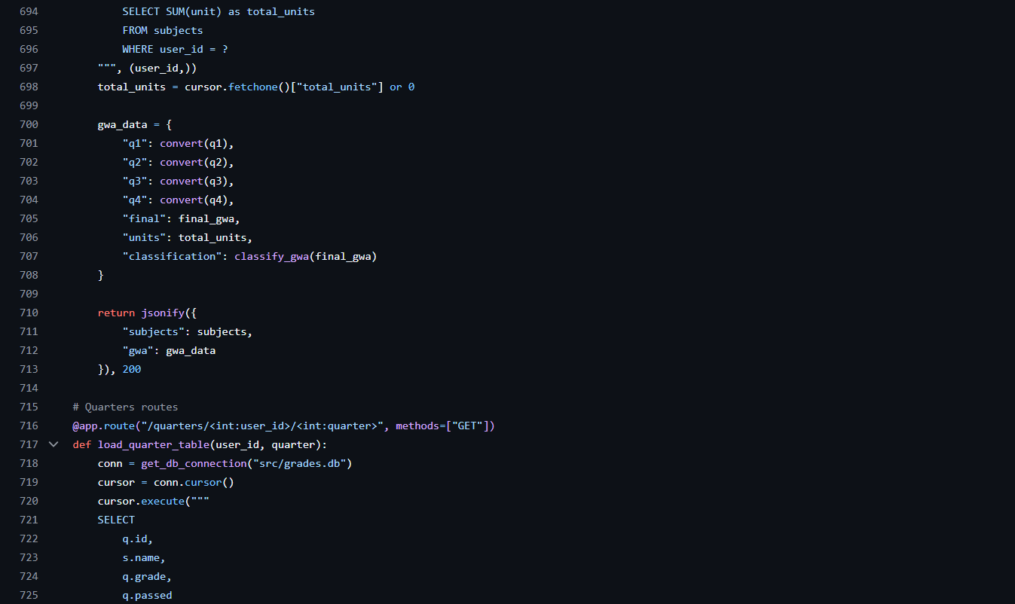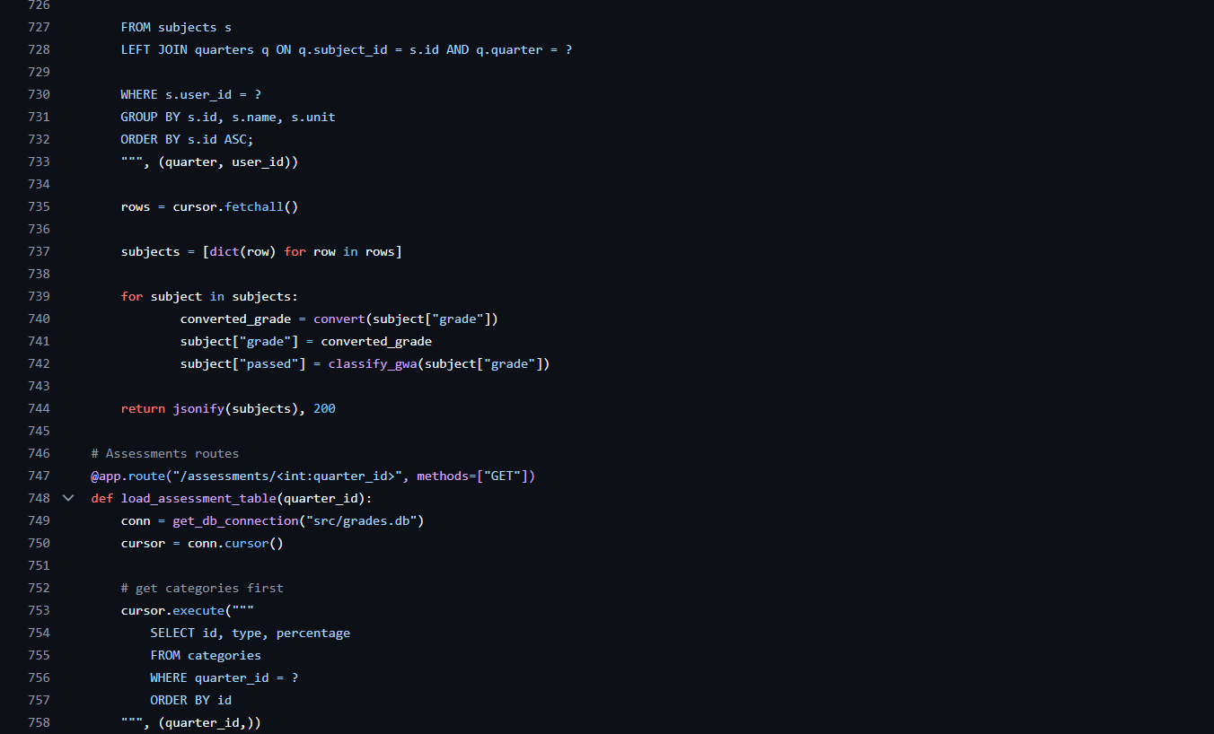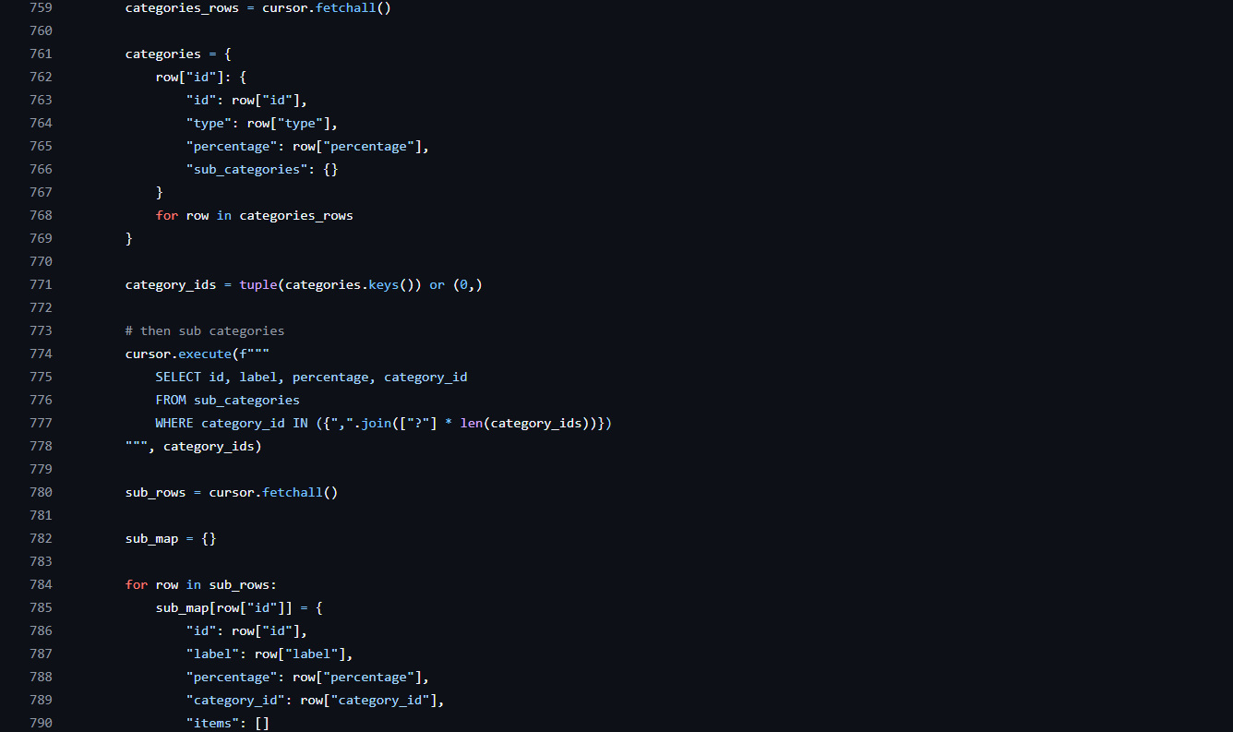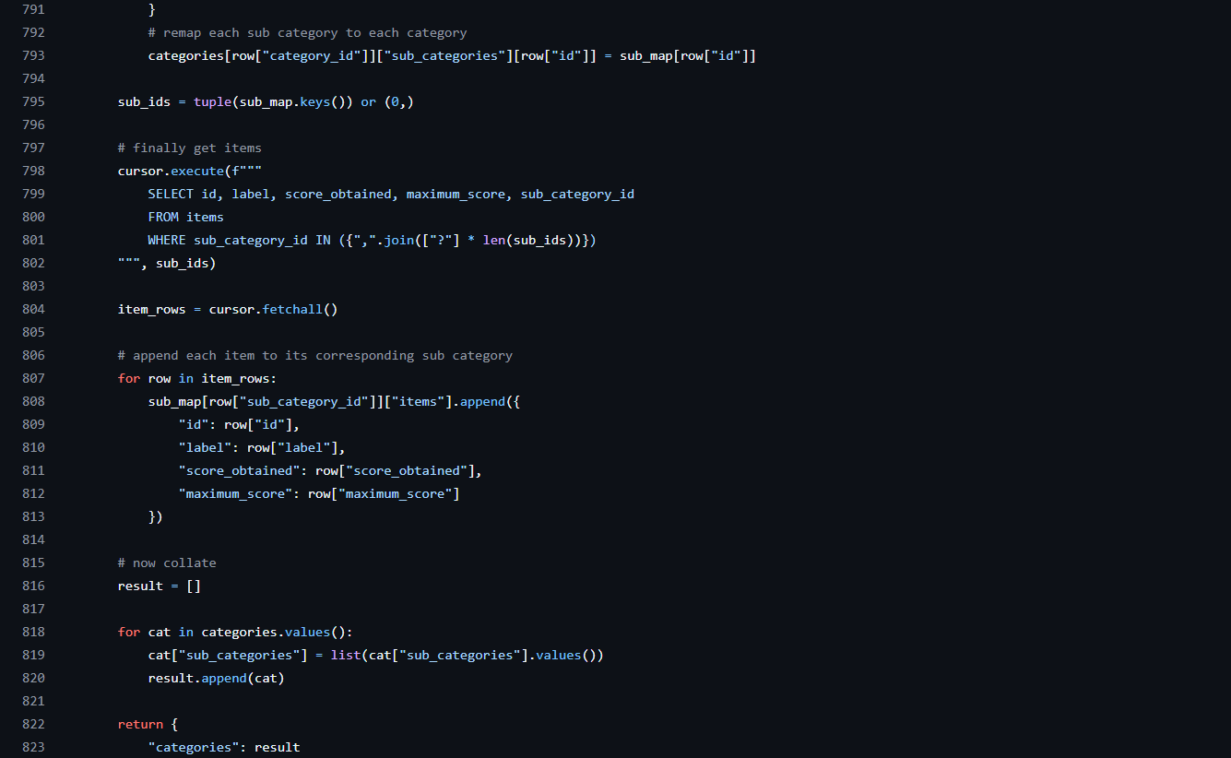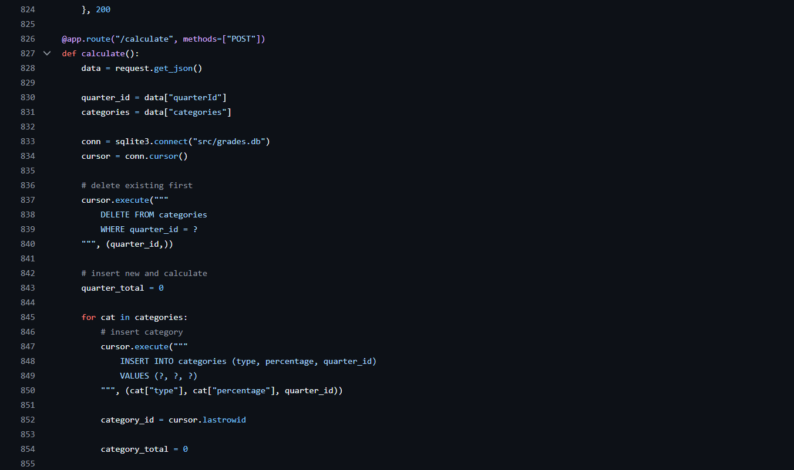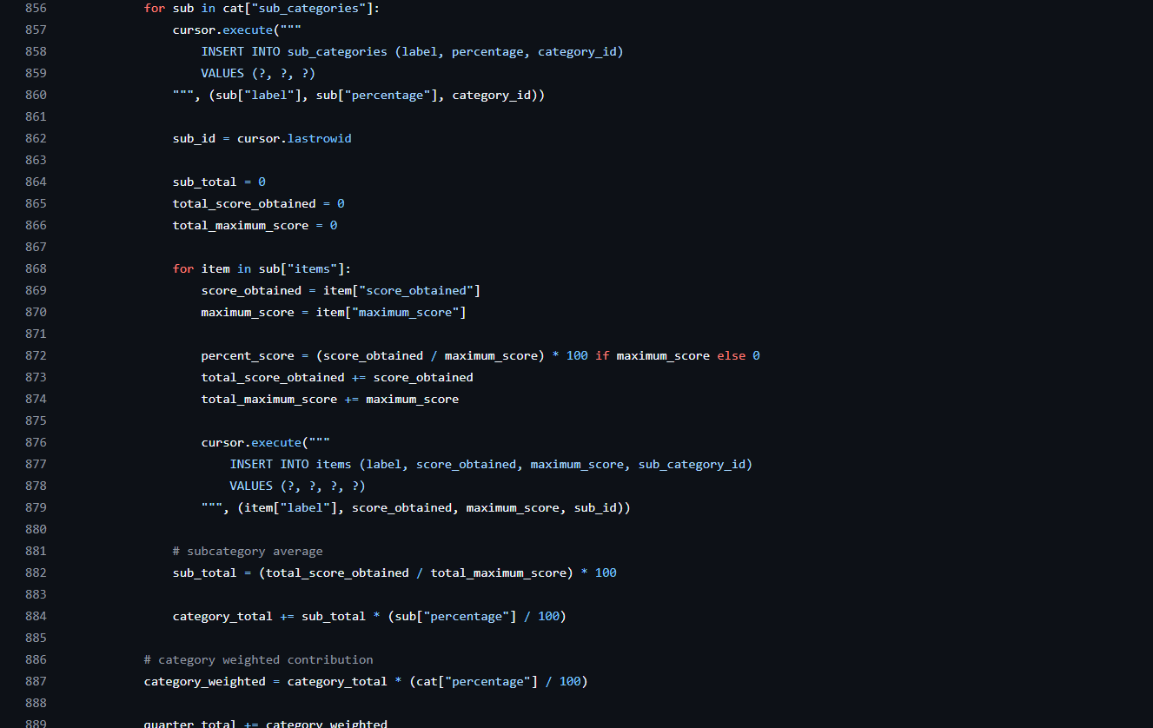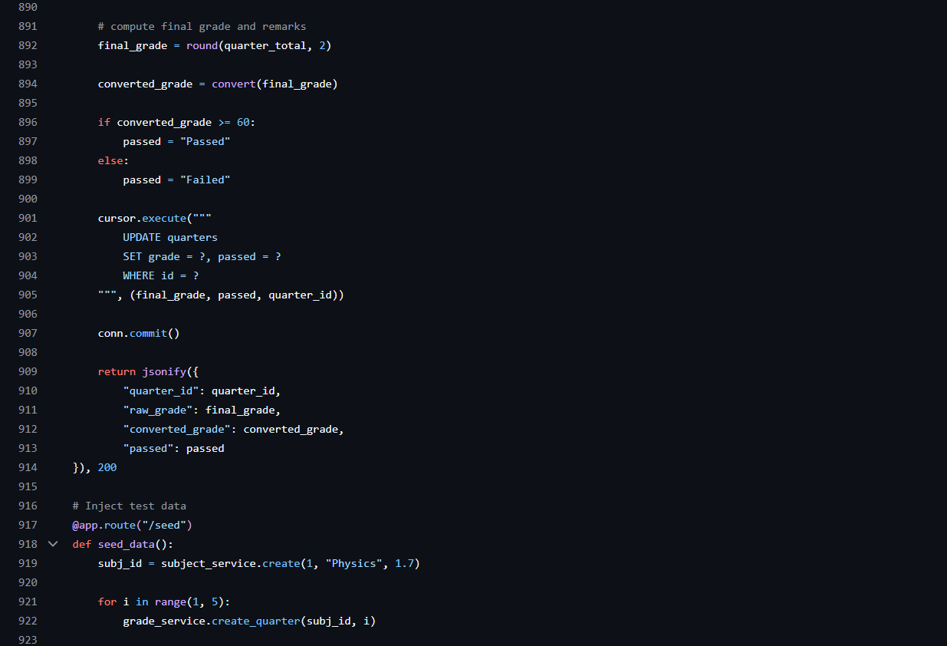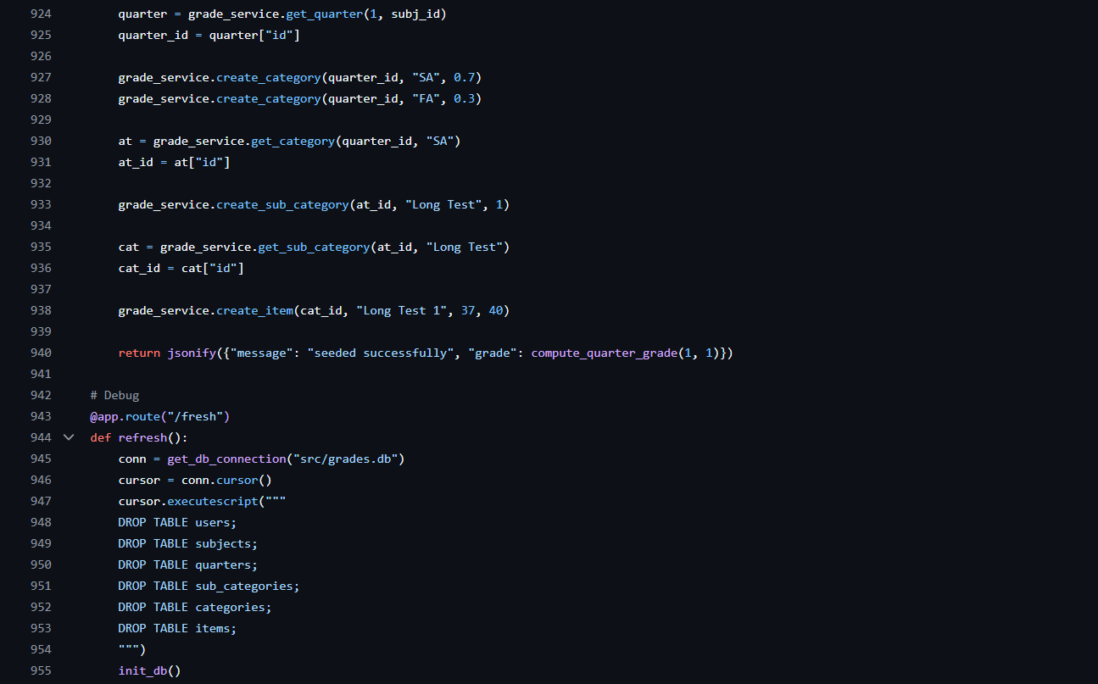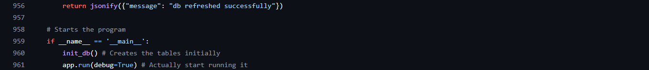

- JavaScript
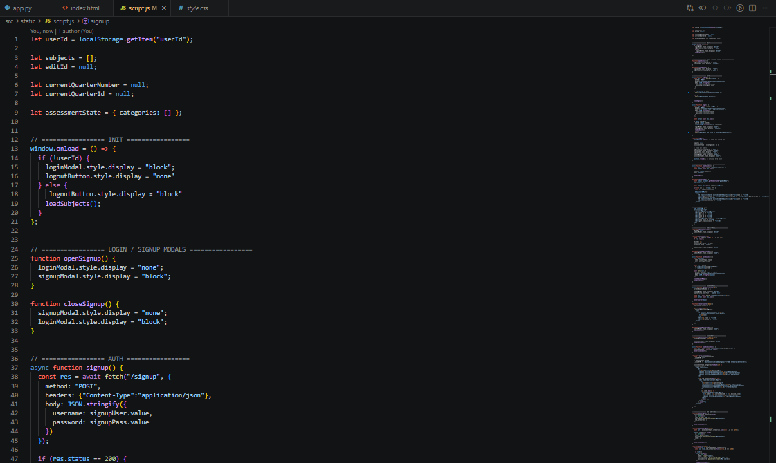
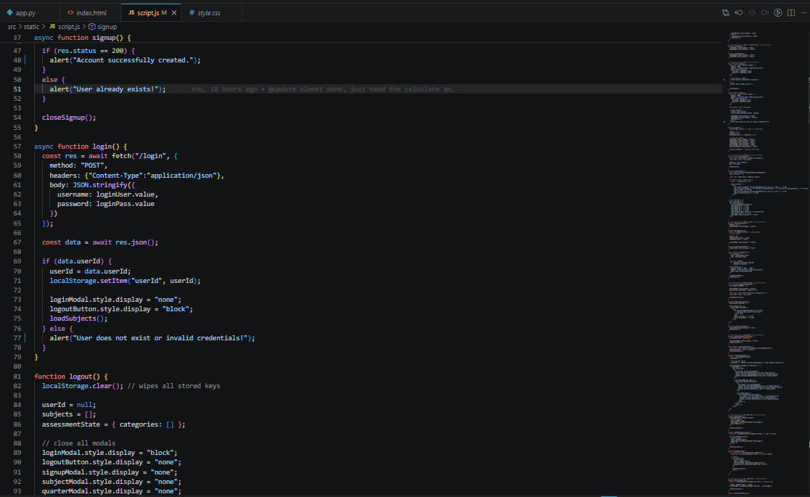
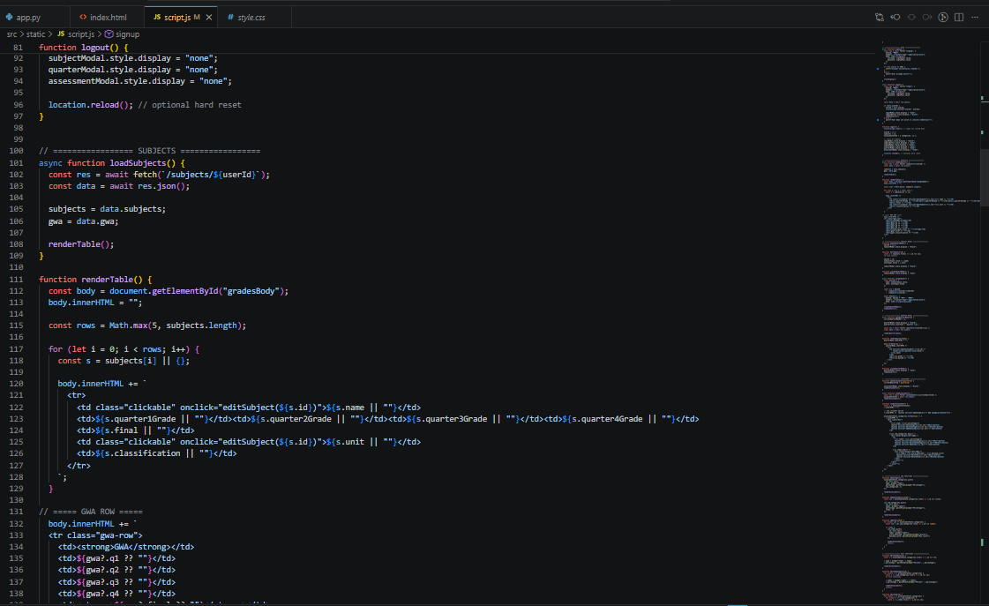
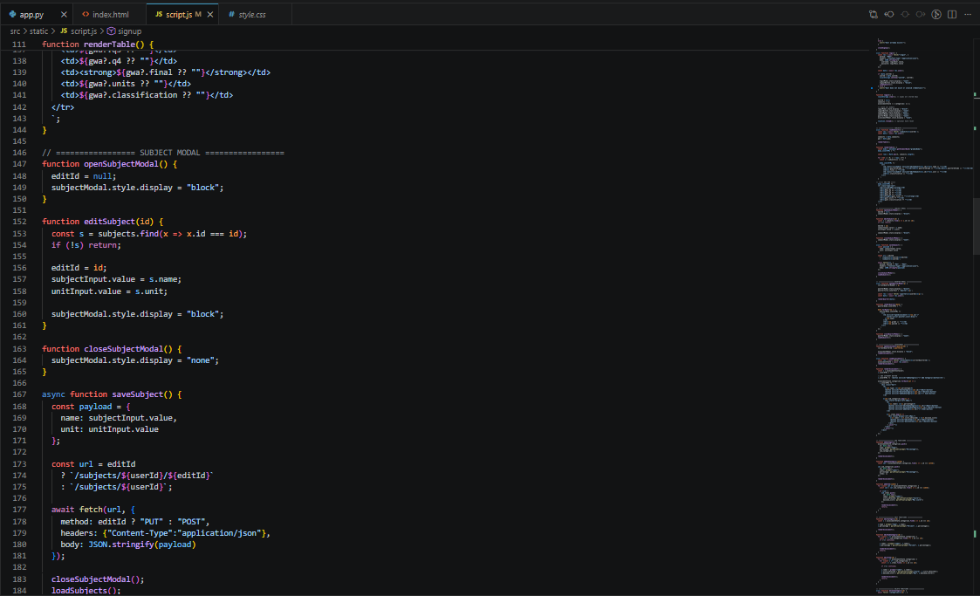
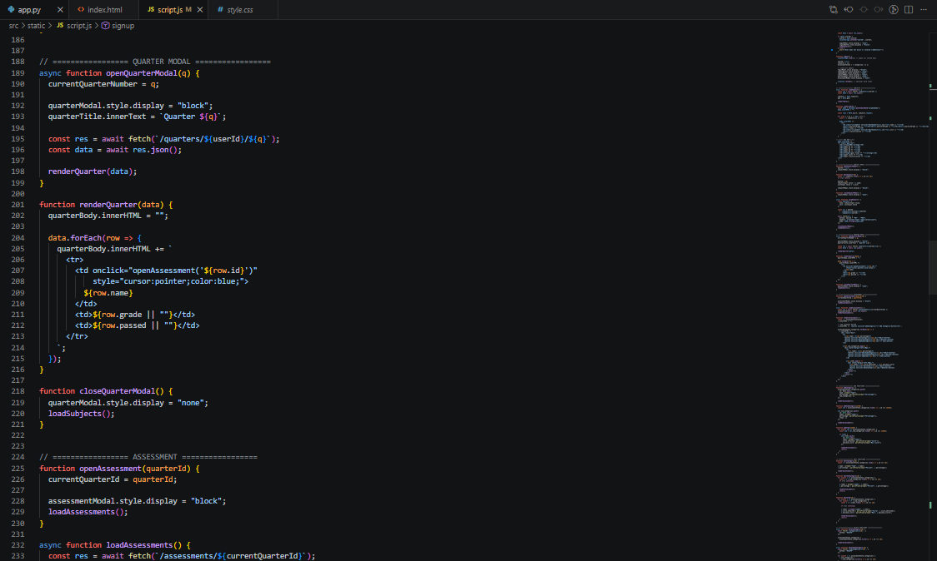
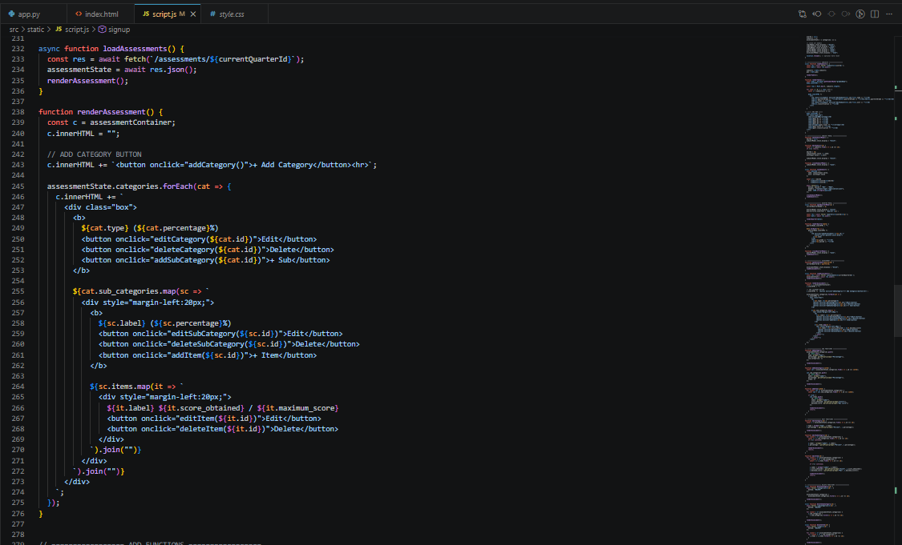
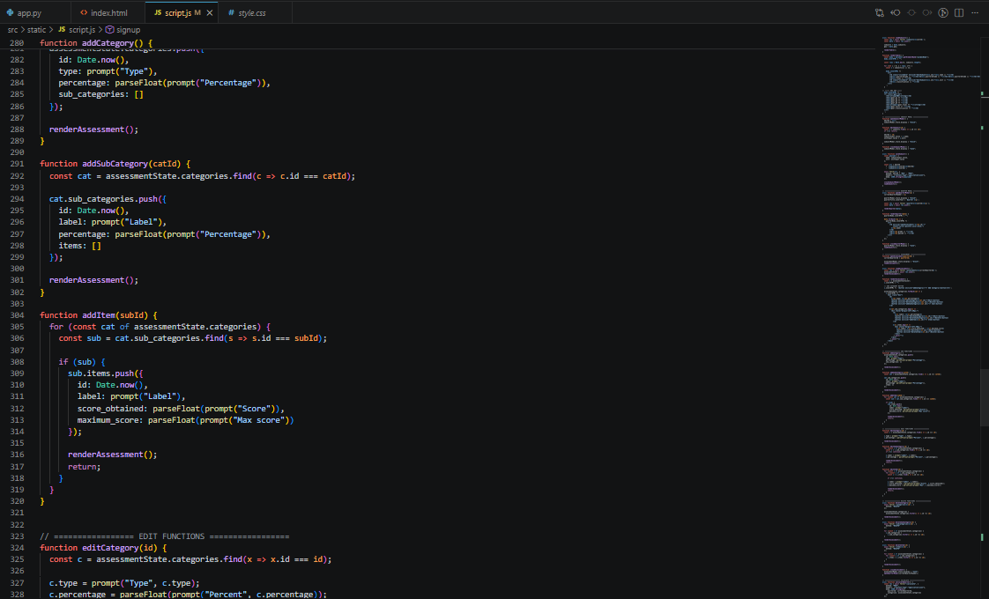
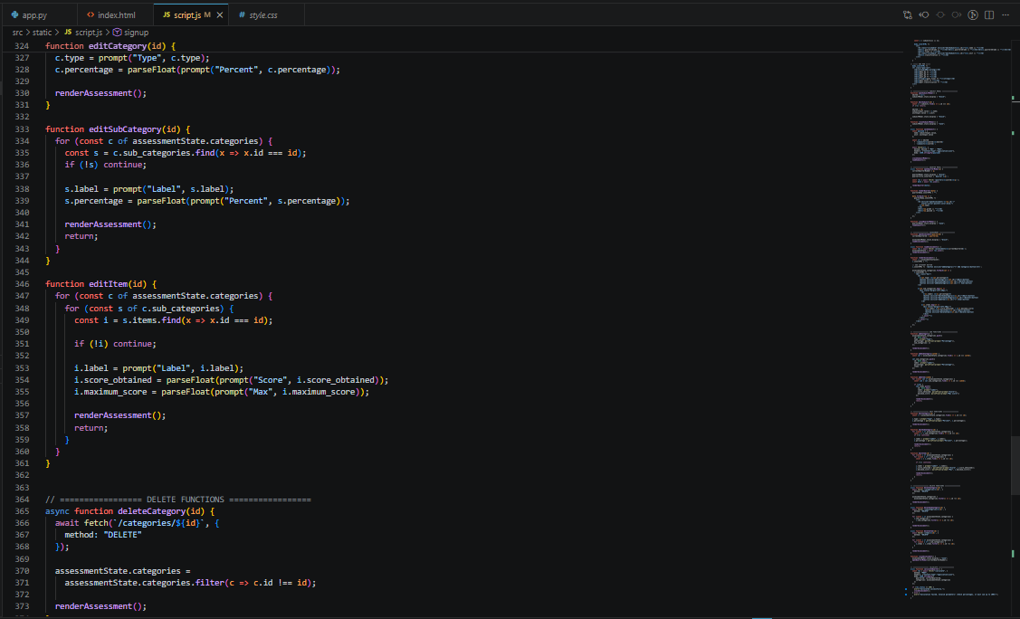
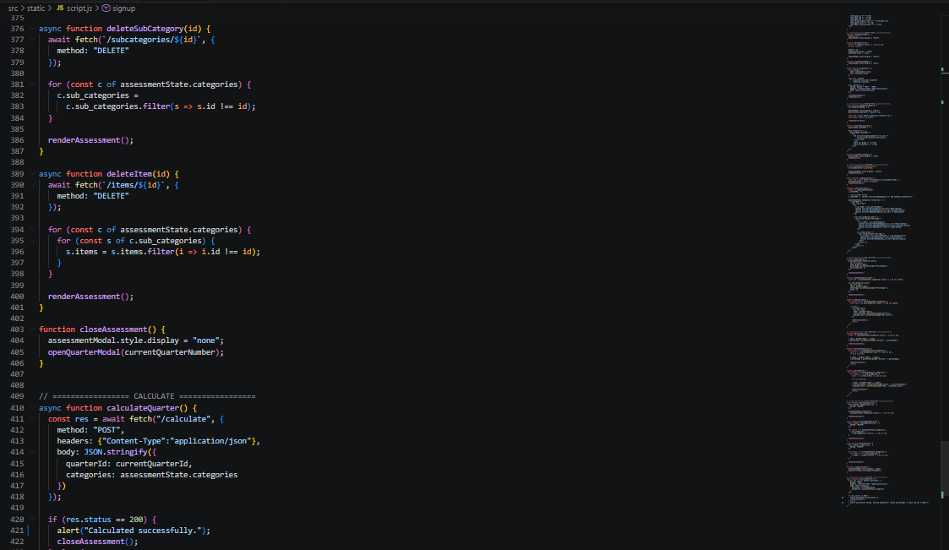
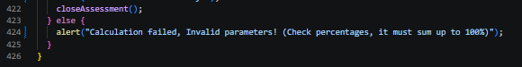
- HTML
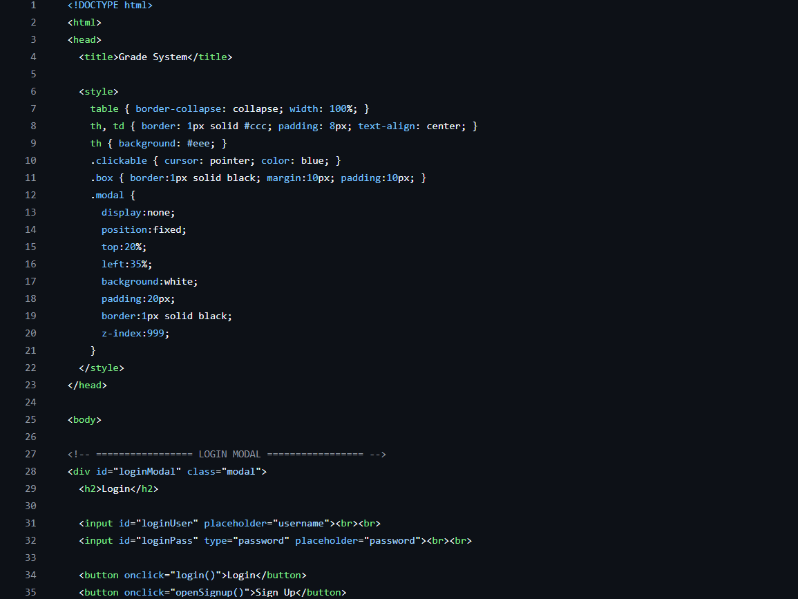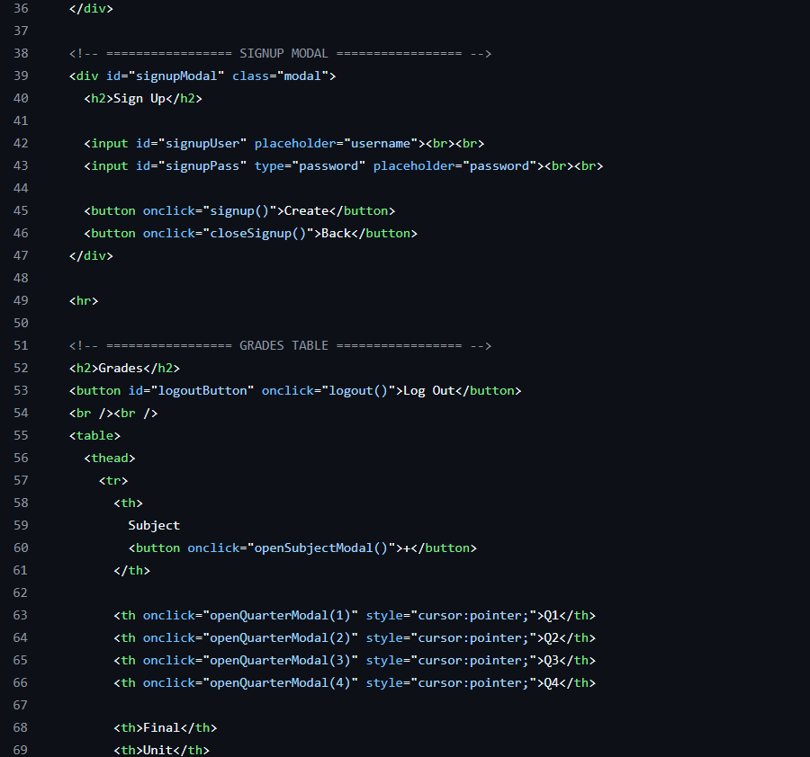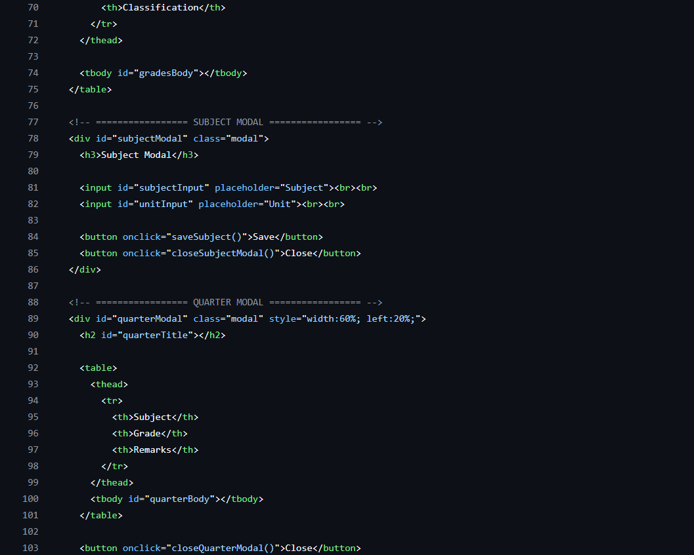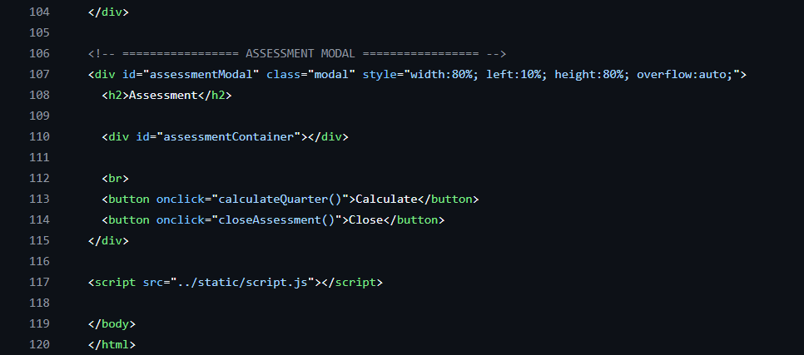

- Team Roles

 | Ibon, Gian | Kasala, Maru | Manalo, KZ | Marasigan, Myke | Melo, Eros
Q1 | Tester | Full-Stack Dev | UI Designer | Leader (all quarters) | Assistant
Q2 | Tester | Full-Stack Dev, Pseudocode | Tester | Writing of Proposal | Tester
Q3 | Tester | Full-Stack Dev, ReadMe File, Additional Documentation | Tester | Assistant Coder, Tester, Additional Documentation | Tester
Q4 | Creation of Flowchart (Final Paper) | Full-Stack Dev,  Problem Statement, Project Overview and Relevance, Methodology, Flowchart (Final Paper), Editor | Creation of Presentation | Problem Statement, Project Overview and Relevance, Objectives of the Study (Final Paper), Editor | Team Roles Table, Flowchart, ReadMe File (Final Paper), Creation of Presentation,

- References

Cloud-Writer. (2025, June 25). Database normalization description - Microsoft 365 Apps. Microsoft.com. https://learn.microsoft.com/en-us/troubleshoot/microsoft-365-apps/access/database-normalization-description?fbclid=IwY2xjawRW9qRleHRuA2FlbQIxMQBzcnRjBmFwcF9pZAEwAAEelgDHaKUxJEm5Wqp-sqx7ly1aAt-Tq2tTDJBkHL-qP-2b2z7ssSIZvYGw1_A_aem_M28JPO_IPD3YQf0WdziVGg
‌

- Readme FIle

https://github.com/alphsa-1/student-grade-calculator/blob/develop/README.md

